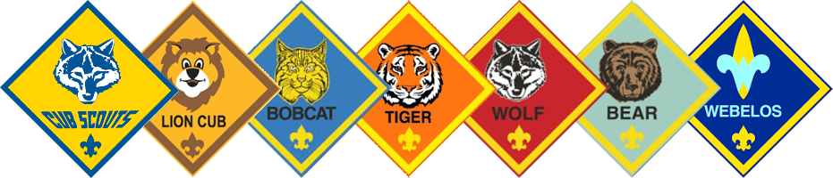
BUILD YOUR ADVENTURE
WITH
CUB SCOUT PACK 305

Pack 305 offers outdoor, healthy living, STEM, and civic engagement activities for kids in Kindergarten – 5th Grade. Scouting is about working together to better our community, make new friends, and learn new things.
www.flpack305.org

Meeting Details

Pack 305 meets on Wednesdays at 6:30 pm at Northside Masonic Lodge #283, 3325 1st St. NE, St. Petersburg, FL (across 34th Ave from North Shore Elementary). There are no meetings during school holidays. First meeting of 2023–2024 is September 6.

Scouts meet weekly in “dens,” or small groups divided by grade, to work on badges and achievements. Once a month, we hold Pack meetings for all dens to come together for special activities. A parent or guardian must stay onsite for each meeting—no drop offs.

Lion Den – Kindergarten
Tiger Den – 1st Grade
Wolf Den – 2nd Grade
Bear Den – 3rd Grade
Webelos Den – 4th and 5th Grade

Our Adventures

- Badges & Achievements: Each den works on adventures from their handbook, which provides achievements that are age-appropriate and help your Scout earn their rank and other special honors. All of our activities come from the Scouting BSA curriculum, and teach values consistent with good citizenship, character development, personal fitness, and leadership.

- Special Activities: Pack 305 also has special outings and events each month. We go bowling together, fish at Fort DeSoto, host wildlife interactions, take eco-tours of the Bay with Tampa Bay Watch, and more! We also participate in at least two service projects a year, such as collecting food for Metropolitan Ministries or removing invasive species from Boyd Hill. We love serving our community!

- Escape the Indoors: Pack 305 has at least two camping trips per year at Scouting-approved campsites in the Tampa Bay area, and many of our activities take place outdoors. We also hold annual outdoor events that allow our Scouts to show off their engineering and design skills: the Recycled Raingutter Regatta (racing boats made out of recycled materials) and the Pinewood Derby (racing customized wooden cars).

How Much Does Scouting Cost?

The fees you pay cover the entire year’s Scouting adventures. We try to make the program as affordable and all-inclusive as possible.

- National youth registration fees / insurance: $138*
- Local Council fee: $25
- Pack dues: $62**

Required total: $225 per Scout

*If you register at a Join Scouting Night, you pay the $138 up front. The rest ($87) is due to Pack 305 by October 1.
**The Pack dues cover your Scout’s badges, awards, and achievements, a Pack 305 t-shirt, the campsite fees for two trips, meeting materials, a Pinewood Derby kit, monthly outings, and summer events.

Your Scout’s Uniform

Scouts wear their Pack 305 t-shirt to many events, but they also have a field uniform available for purchase from the Scout Shop. www.scoutshop.org

Kindergarten through 3rd Grade Scouts simply need a field shirt, kerchief, slide, belt, and any navy shorts (they do not have to come from the Scout Shop). Webelos in 4th and 5th Grade need the khaki field shirt, kerchief, slide, belt, and olive green shorts.

If you would like Pack 305 to purchase these on your behalf, please see Pack leadership for associated costs.

Want to Join? Want More Information? Contact Us!

bsapack0305@gmail.com
727-314-3055

