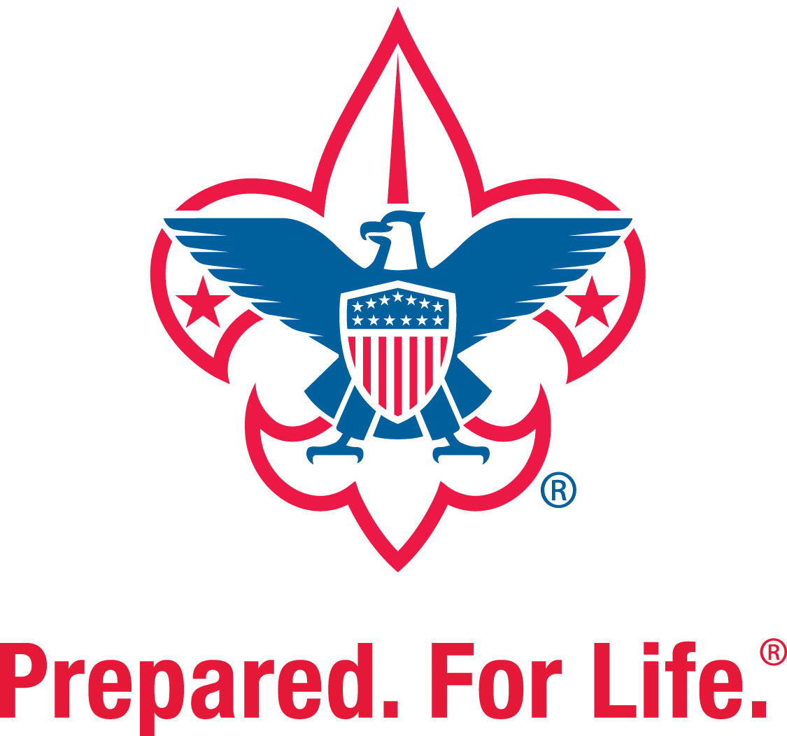
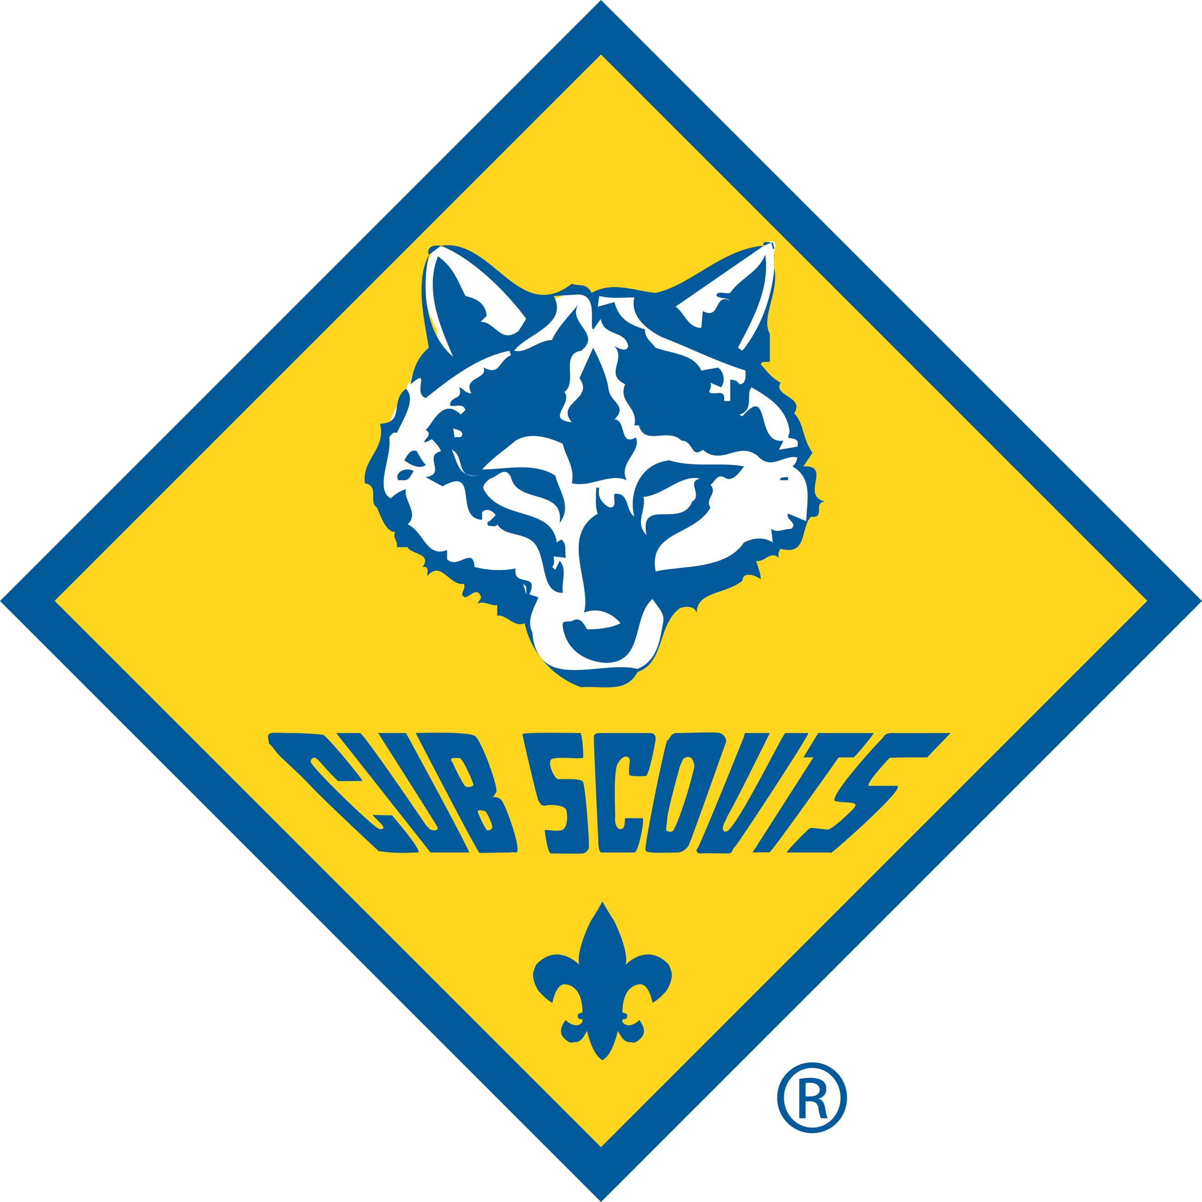
Getting Started with Pack 305
2021-2022 School Year

Come join us and find out how Cub Scouting is fun for the whole family!
Pack 305 offers a way for our kids to explore their communities, enrich their understanding of the earth, and cultivate new friendships. We focus on preparing them for today – and for life.

Meeting Details:
All meetings take place Wednesdays at 6:30pm, at Northside Masonic Lodge 283, located at 3325 1st St. NE, St. Petersburg, FL 33704, next to the Masonic Home (across from North Shore Elementary).
Parking is available in the main lot of the Masonic Home, with an entrance off 1st St. NE. The small white building on the corner next to the Home is the Lodge. Enter the front door and turn left for the meeting hall.
Dens
Kindgergarten – Lions
1st Grade – Tigers
2nd Grade – Wolves
3rd Grade – Bears
4th Grade – Webelo (Year One)
5th Grade – Webelo/Arrow of Light

Den meetings are led by a Den Leader and involve a small group of boys or girls, all in the same grade. On each month’s 3rd Wednesday, the meeting is with the full Pack to come together for fun activities, monthly updates, and group info.
Dens for Girls have not yet been formed in our Pack, as there are additional structure requirements. If you are interested to have your girl join Pack 305, we ask that you help out as one of our leaders - we’d love to have your help to welcome girls into Cub Scouting!
Pack 305 is not a drop off program and a parent/guardian must stay onsite for each meeting.

Some important links as you decide whether Scouting is right for you are included below.
- Check out our Pack website (constant work in progress!): www.FLPack305.org
- All about being a Cub Scout: http://www.scouting.org/scoutsource/CubScouts/CubScouts.aspx
- Learn about our host and Charter Organization, Northside Lodge 283 here: http://northsidelodge283.org/
- Our Tampa Bay Area Council page is a great place to learn more about local Scouting activities: https://tampabayscouting.org

Program Details:
Pack 305 is proud to offer an all-inclusive experience of the Scouting Adventure! We’ve carefully considered all the various costs* associated with participation in the Cub Scout Program and are pleased to provide our families with the opportunity to enjoy it all without fishing out your wallet for each event.
New Members | *Fees include BSA registration, BSA new member fee, insurance, uniform (see below), Council fee | New members submit application with payment. Applications are accepted on a rolling basis all year | TOTAL: $200
Returning Members | Fees include BSA registration, insurance, Council fee, ranked uniform pieces | Returning members’ fees are due September 30 | TOTAL: $105
OPTIONAL | Popcorn buyout—if you are a member of the Pack who does not want to sell popcorn | Popcorn buyout due October 15 | TOTAL: $180

Pack 305’s Annual Youth Membership includes (for one parent/guardian and one child)
- BSA Membership Fees, Council fees, and insurance
- (1) Youth Pack T-shirt & Field Uniform – patches, shirt, belt, neckerchief, slide, Webelos colors
- Den Handbook
- Pinewood car (1 car, including weights, excluding paint)
- Den and Pack meeting activity materials
- Advancement / Recognition / Awards (belt loops, patches, prizes, etc.)
- Online Accessibility to Advancement Tracking (Scoutbook: https://youtu.be/dNr_mIHXDi8)
- Managed Recruitment and Trained Pack Leadership
- Sponsored Service Projects / Community Support
- Summer Events (1 per month in place of meetings)
- Camping Events (campsite fees are included, but meals and personal items are the family responsibility):
  - (3) all ages camping trips – (1) day camp, (1) single night, (1) two night
  - (2) Webelos and Arrow of Light trips, both two nights

Family Responsibilities
- Youth Member’s hat and socks (optional items)
- Youth Member’s navy shorts / pants (required)
- Adult Pack T-shirts (optional, although recommended)
- Fundraising participation (required or buyout

We recognize the importance of ensuring all parents who step up to be leaders in our Pack family are able to fully participate with their own child(ren), and encourage all family members to take an active role. It takes many hands to make light work, and our volunteer leaders are the grease for the wheels!!

Uniforms – Activity and Field
Official Cub Scout Uniform optional components can be purchased online at http://www.scoutstuff.org/ or at the Tampa Scout Shop. Both online and the Tampa Shop are officially licensed Boy Scouts of America (BSA) stores. https://tampabayscouting.org/shops/tampa-scout-shop
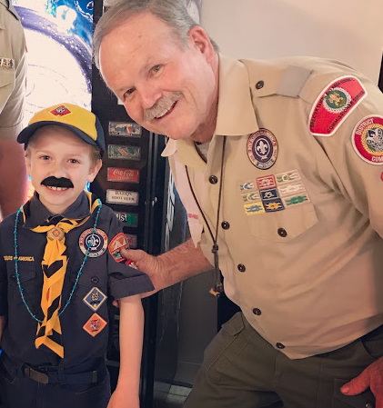
The Pack 305 t-shirt must be worn by Adult Leaders and Youth Members to Den meetings, outdoor events and clean up type activities.
Red Shirts are for Den and Committee Members, and the Blue Shirts are for Youth Members, Family and Friends.
Field Uniforms are required for all Den Leaders and Youth Members at Pack meetings, parades, banquets,
and other more formal activities.
- Pack 305 provides the required Uniform components except shorts/pants. The hat and socks are optional and are to be provided by the Family. Shorts/pants must be purchased by the family and can be any style in navy color.
- We have some donated items available, as well as an inventory of patches and other accessories. Please ask a Pack Leader for assistance.
See details for what is required here: https://www.scouting.org/programs/cub-scouts/cub-scout-uniform/

A limited number of paid Youth Membership sponsorships
are available, pending Pack 305 Committee approval.
- To request assistance, send an email to BSAPack0305@gmail.com explaining the level of sponsorship needed (full or partial) along with supporting documentation
- Every request will be reviewed by our Treasurer, Cubmaster and Committee Chair; and assessed on its own merit.
- If approved, the application process remains the same with an additional requirement to complete Level Two volunteer status and a set number of volunteer hours. The quantity of hours will be communicated upon approval, and is dependent upon the level of sponsorship.

Fundraising and Community Service
Our primary fundraising initiatives are Popcorn and Aluminum Can Recycling. We also recommend selling our Pack t-shirts and sweatshirts to friends and family!
- Aluminum cans are collected (bring them to a meeting!) and turned in for recycling year round. Payments from the aluminum is 100% deposited to the Pack bank account.
- The blue Pack 305 t-shirts are $20 and sweatshirts are $30. All sizes, same price.
Service Projects may be combined with other activities. We primarily focus on projects which will benefit our Charter Organization, Northside Masonic Lodge 283. Other activities include park clean ups and Greater Tampa Bay Area Council sponsored events.
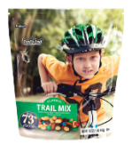
Program costs are offset by our fundraising efforts via the BSA National Popcorn Program with TrailsEnd.
Each family has a $700 sales goal OR the option to buy-out for $180.
If you decide to participate in selling, the expectation is that your child makes an effort to fully reach the goal.

Popcorn sales kick off is in late September, with active sales all through October. https://tampabayscouting.org/resources/fundraising/popcorn

How does the cost for Scouting compare?

Pack 305 recognizes that your family has choices, and making one on behalf of the little ones can sometimes be daunting with so many options. Little League? Soccer? Karate? Dance? How many activities you can sanely fit into a week surely depends not only on your other personal commitments, but also the budget.

Check out this chart and see for yourself that an investment in Scouting is not only beneficial for your child, but also for your budget! https://www.facebook.com/TheDudeMom/posts/10156614317800979

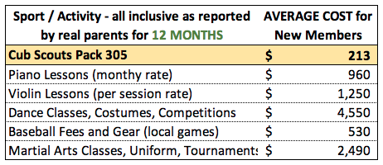

PACK 305 CONTACT INFO:
727-314-3055
BSAPack0305@gmail.com

Erin Mauldin, Committee Chair
Patricia Scott, Cubmaster

